**Sunkari Manohar**

**Aditya Institute of Technology and Management**

**Assessment 6 - 09/12/23 .**

Today we discussed about

**Sub Totals :**

* group by roll up
* Grouping

**GROUP BY:**

**Group by roll up - used to calculate sub totals:**

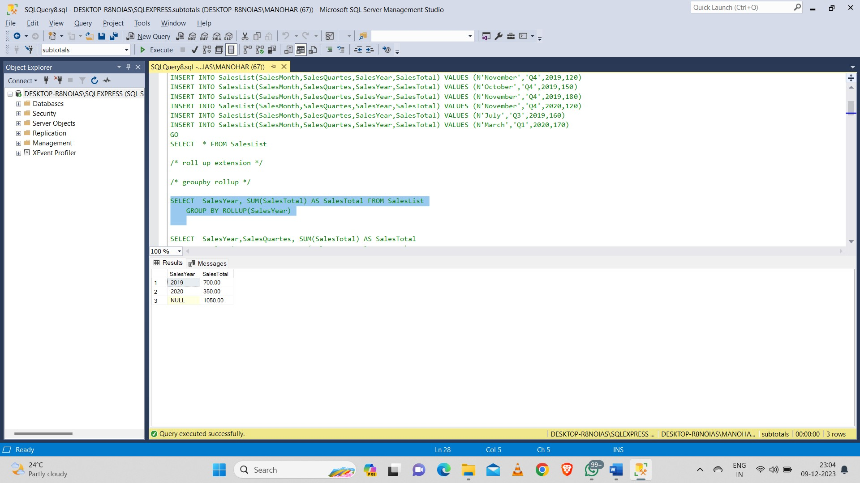

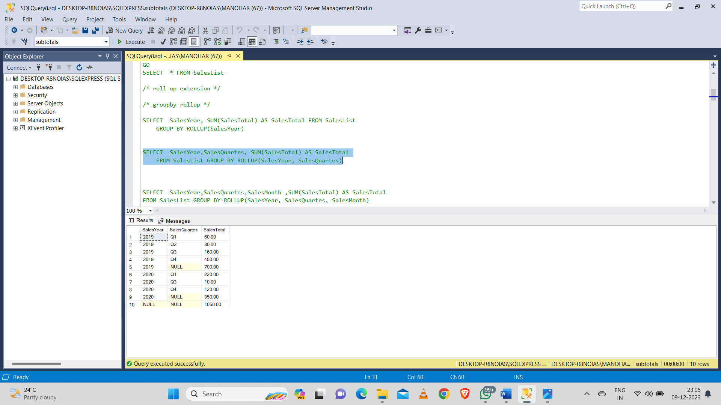

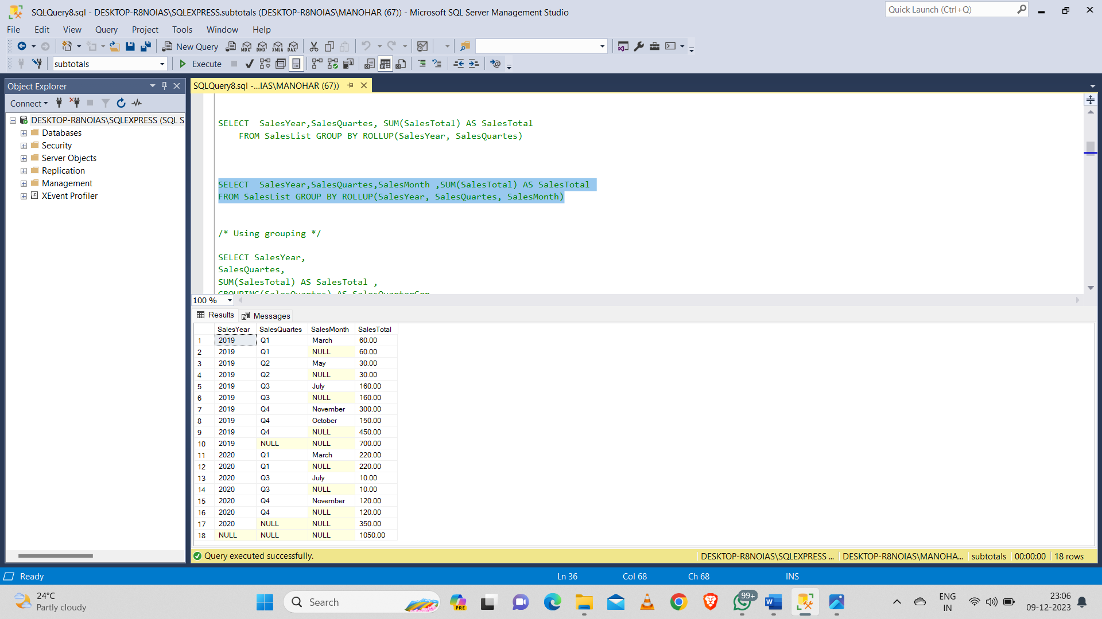

* **Grouping function to calculate sub totals :**

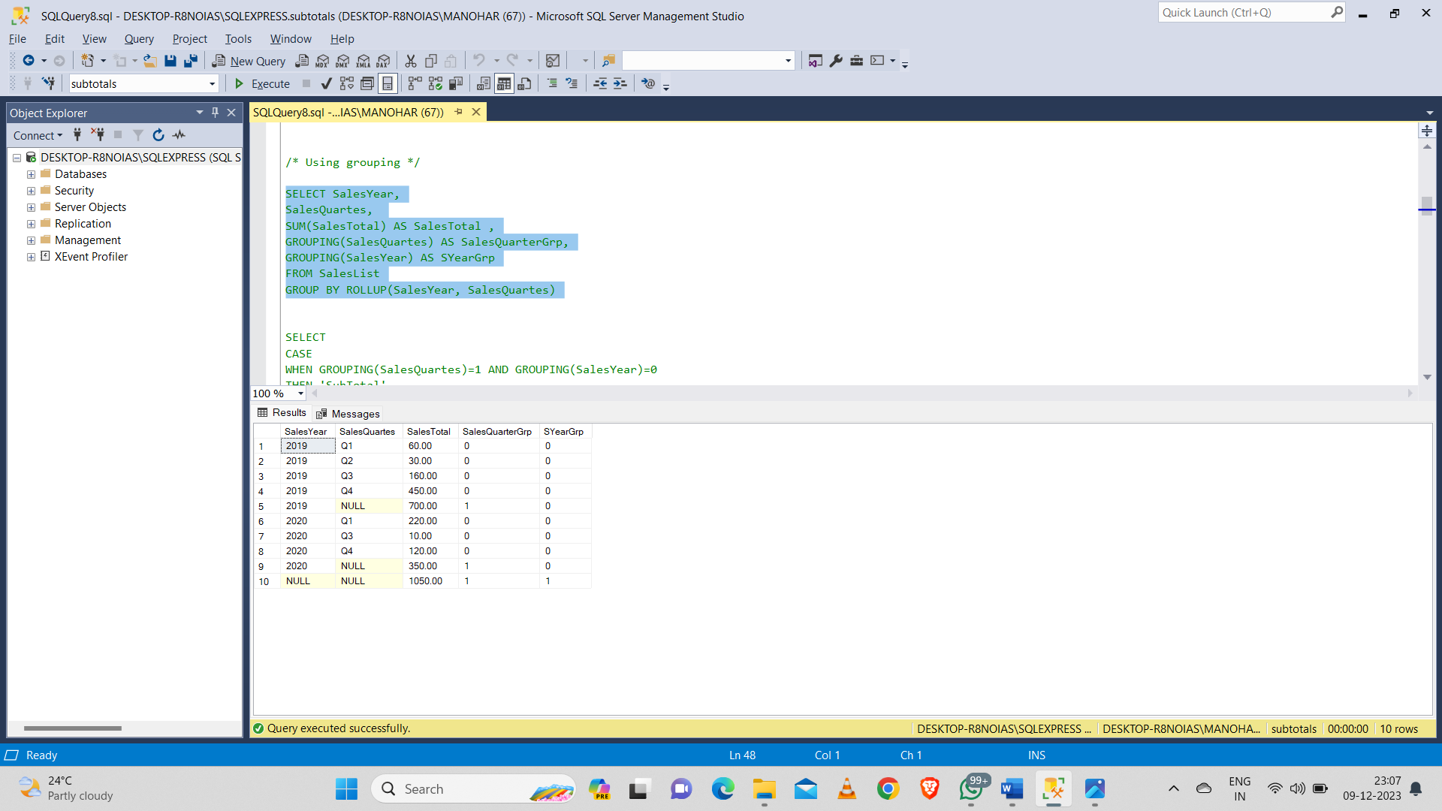

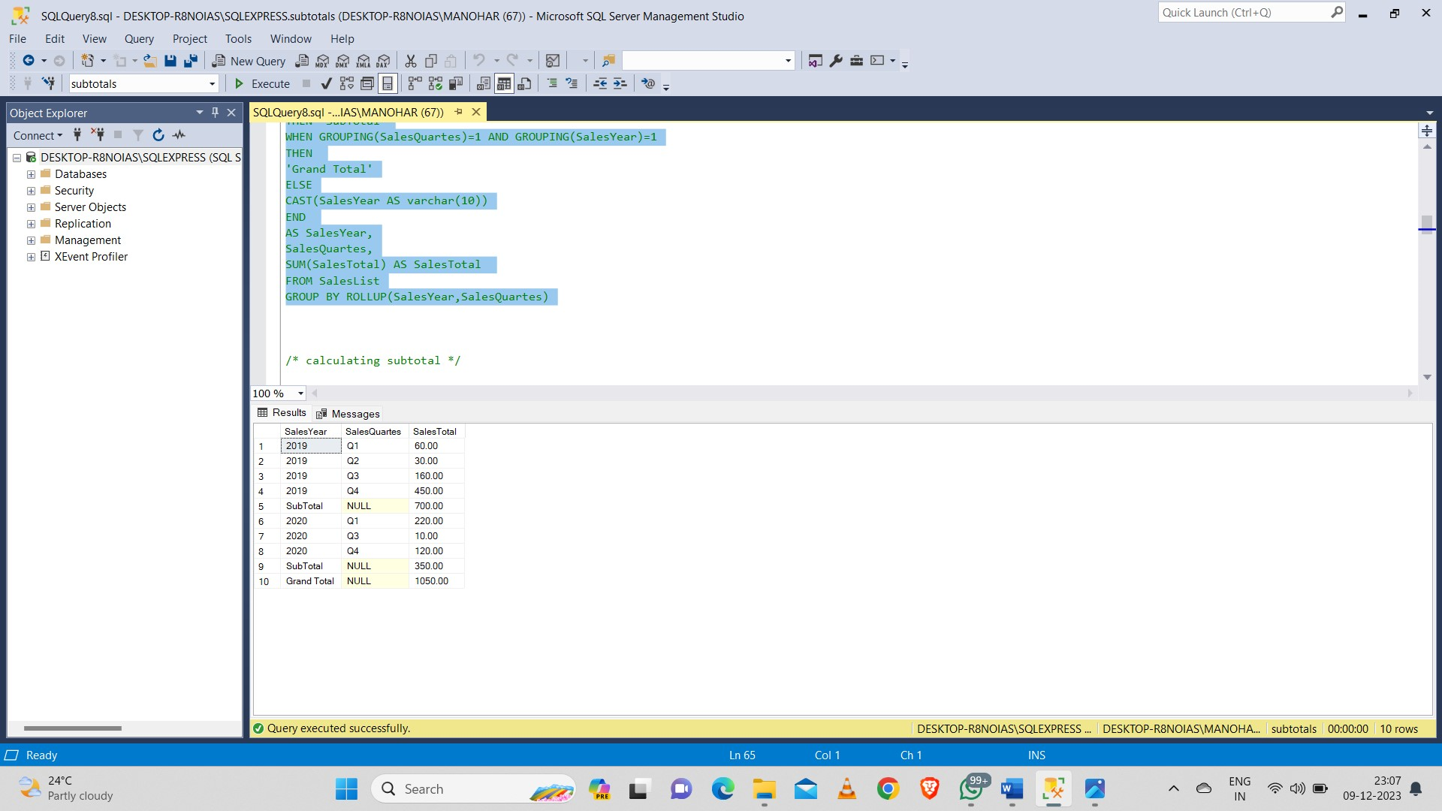

**Calculating subtotal for one column using row number() and newid():**

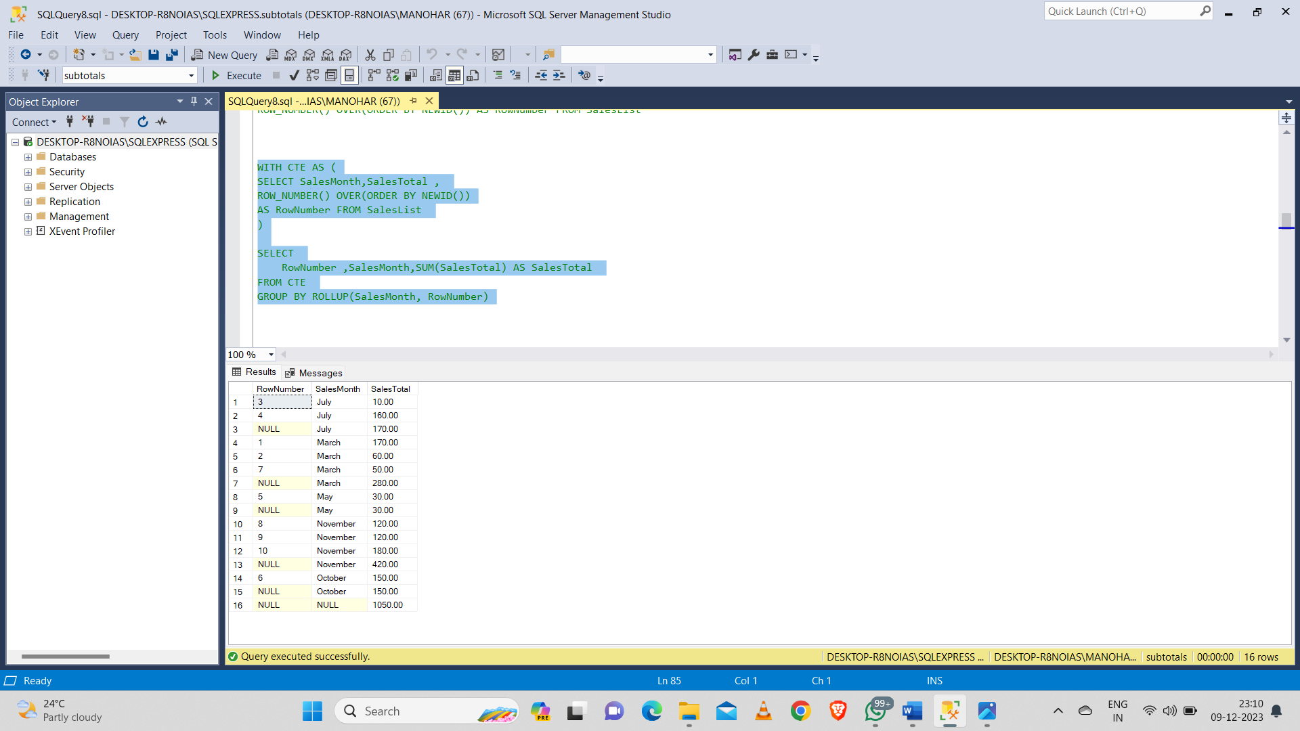

**Common Table Expressions (CTE):**

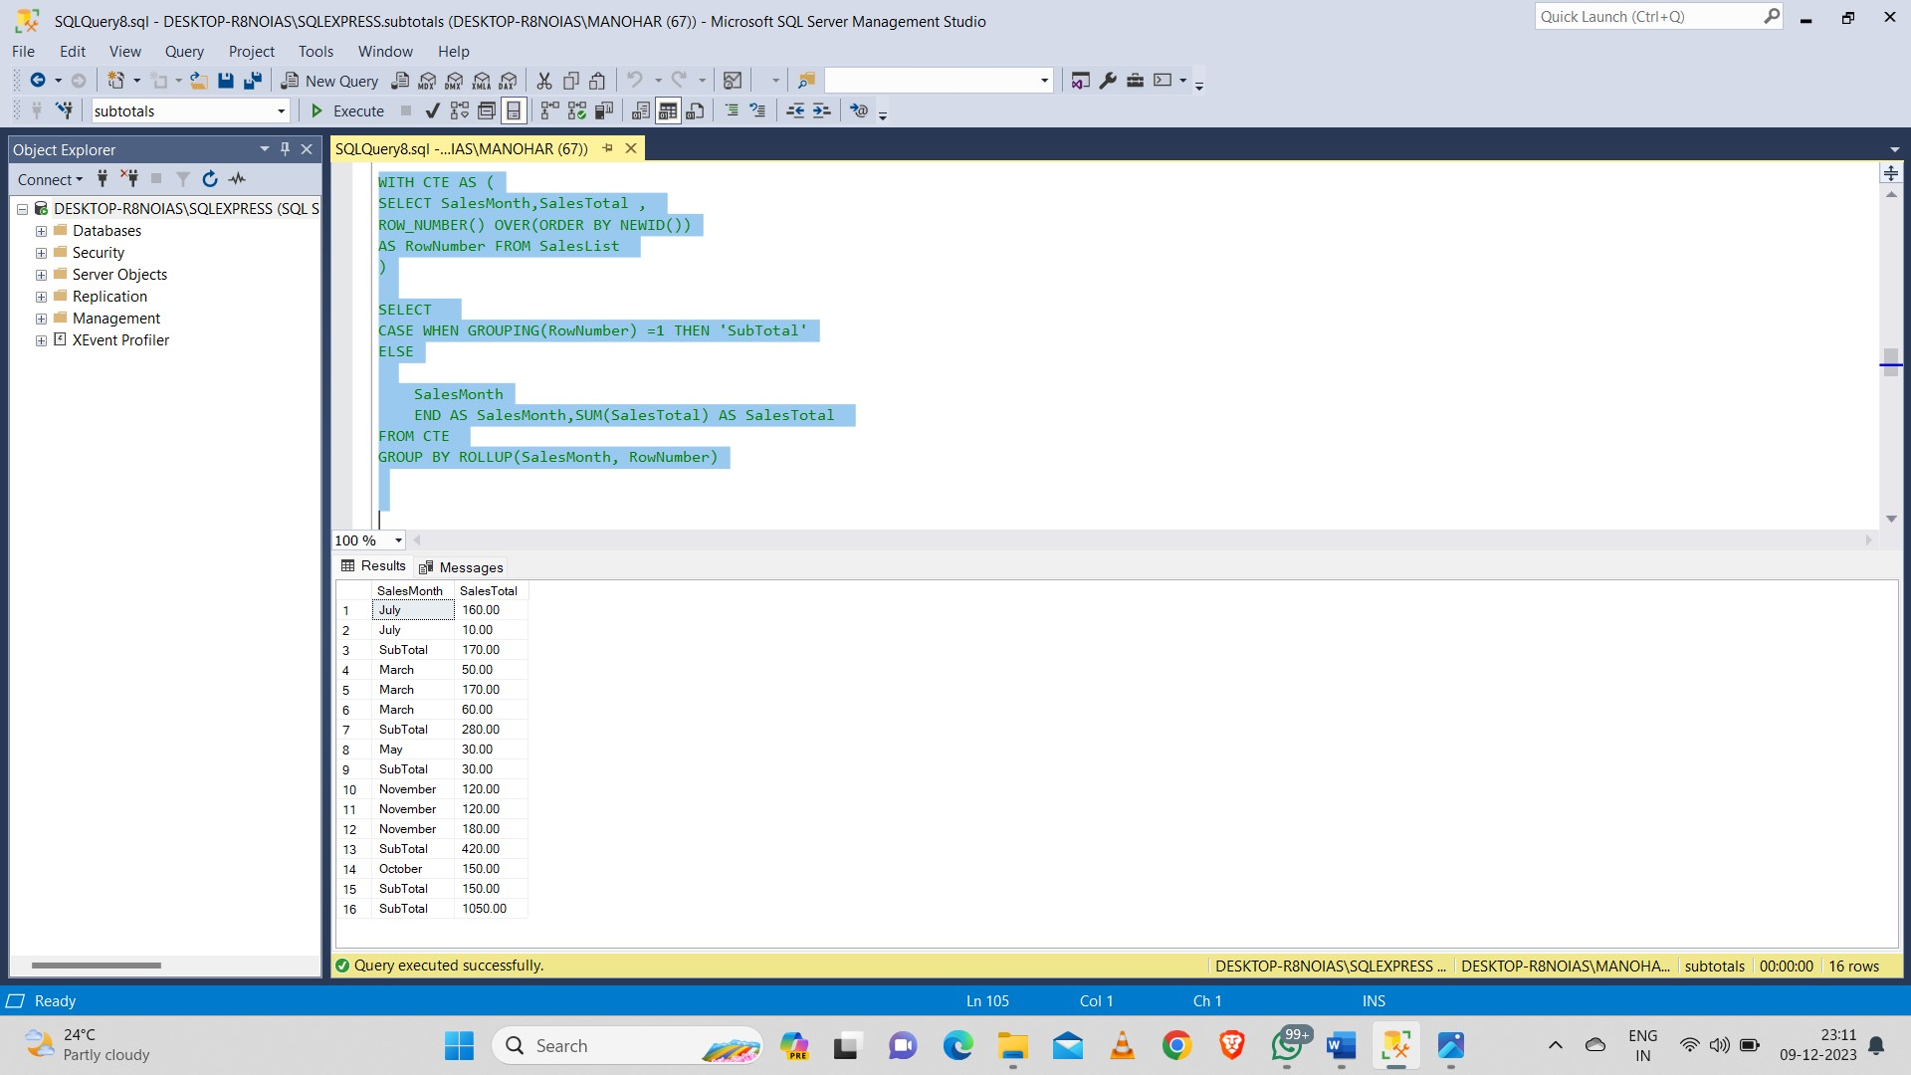

**Cast() :**

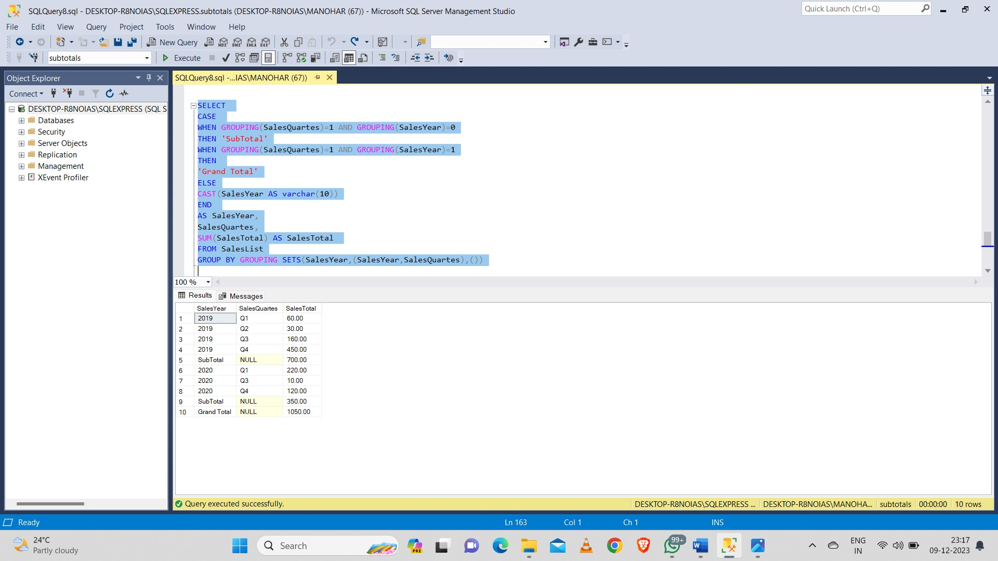

**Stored Procedures :**

**Stored procedure with single values:**

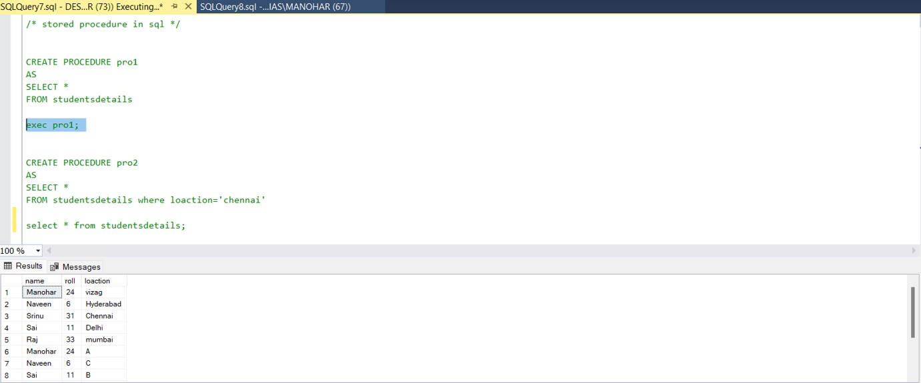

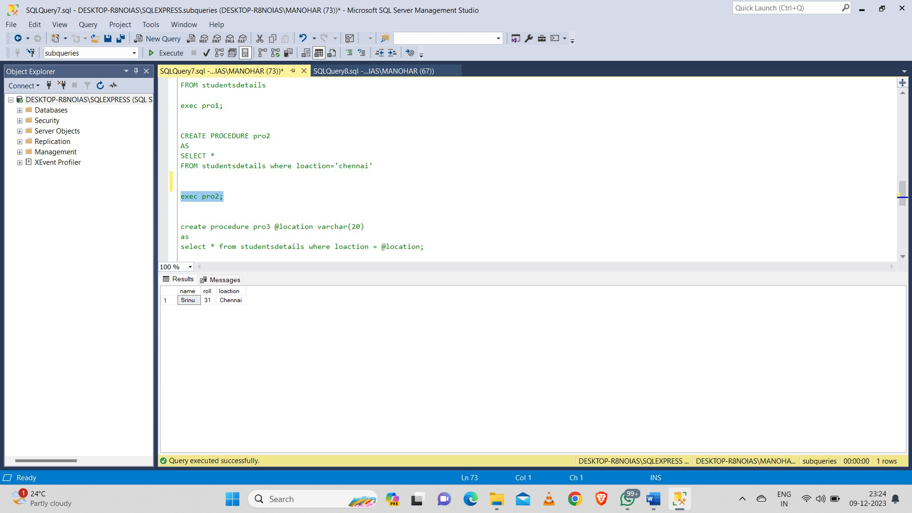

**Stored procedure with single variables:**



**Stored procedure with multiple variables:**

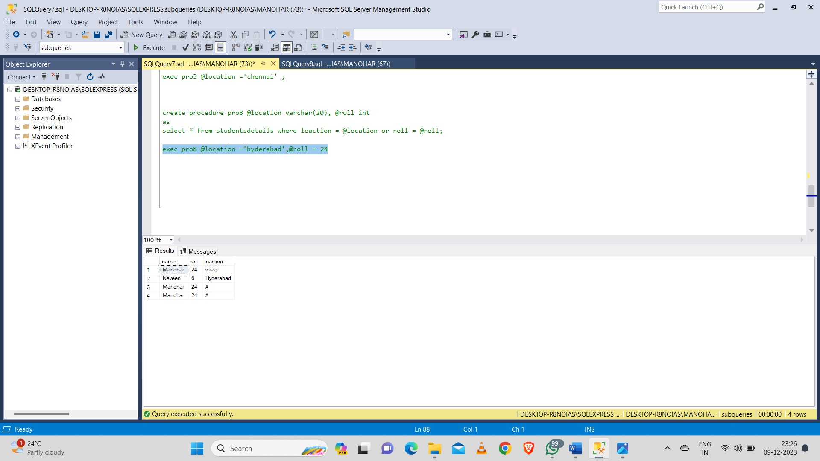

**Correlated Queries:**

